Description
The mission analysis module is the core analysis tool in the aircraft design process. The mission analysis takes place in the aircraft design loop. Main requirements for this tool are the short execution time and the robustness of the tool. Due to these constraints, the mission analysis tool is kept simple. This results in possible optimization potential for the given aircraft. Additionally, this methodology does not take off-design missions into consideration.
To catch this potential, possible mission optimization parameters need to be identified outside of the aircraft design loop. A methodology to calculate the optimization potential of the identified parameters needs to be developed. Finally, the optimized mission parameters should be fed back into the design loop to check the effects of the optimized mission on the aircraft design. In the optimization process, not only the design mission must be considered but the influence of the design mission on the off design must also be investigated using provided operational data.
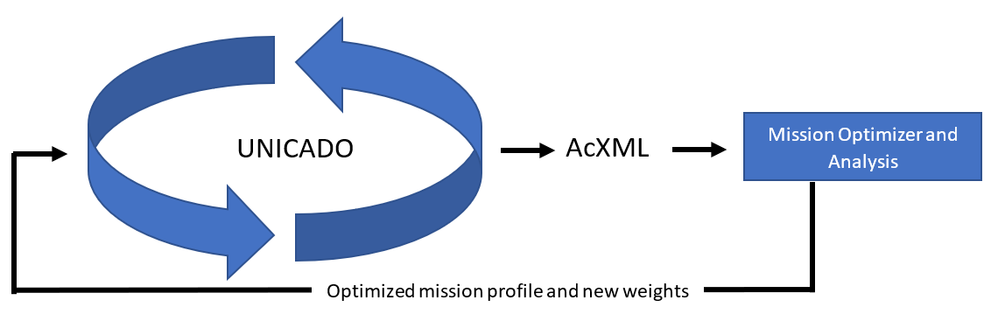
For this, a literature research on aircraft operations with focus on mission specific optimization potential must be contacted. Afterwards, the UNICADO environment must be installed and the overall aircraft design process must be understood. A special focus must be on the mission analysis tool.
Based on this, a mission optimization tool must be developed employing UNICADO aircraft data. The optimization should then be done using identified mission parameters. In a last step, the optimized mission is considered in the aircraft design loop. A comparison in between the two converged aircraft should be done. Optionally, different aircraft designs can be considered.
Scope of Work
WP1: Literature research
WP2: Familiarization with UNICADO
WP3: Identification of mission specific optimization parameters
WP4: Implement the Optimization Framework outside of UNICADO
WP5: Integrate the optimized mission into the design loop
WP6: Compare the designed Aircraft
WP7: Documentation and Submission
Supervision
Meric Taneri, Tobias Weckenmann
Student Signature:

________________________________

